Java static->

* The **static keyword** in java is used for memory management mainly.

* We can apply java static keyword with variables, methods, blocks and nested class.

* The static keyword belongs to the class than instance of the class.

**1.java static variable->**

*If you declare any variable as static, it is known static variable.

*The static variable can be used to refer the common property of all objects

*(that is not unique for each object) example->company name of employees,college name of students etc.

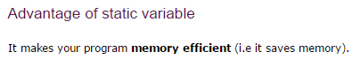

**\*the problem without static->**

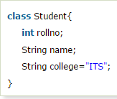

In this if I make a java project and in there 5000 objects then all 5000 objetc are has the same college name

So its will consume 5000 objects memory space.so if we make it static it will go to the class and this will take memory for once.

Example of Static variable->

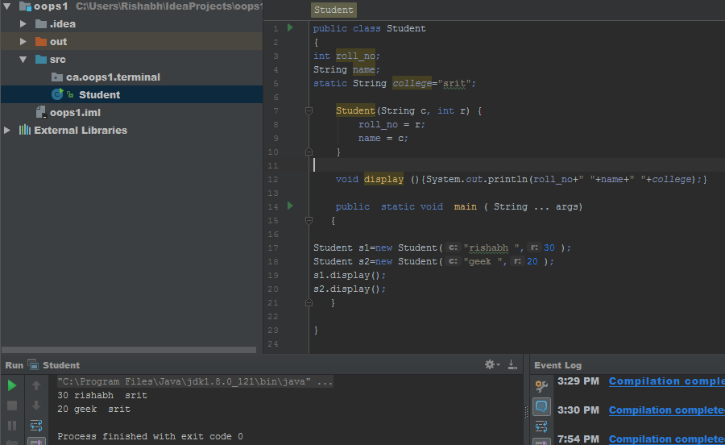

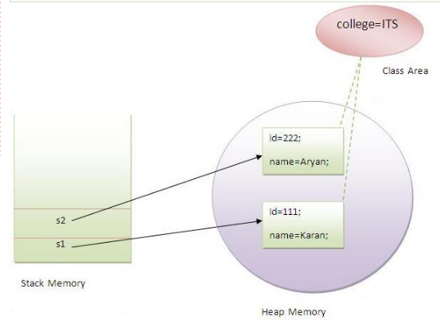

Static element go after in class area after being static;

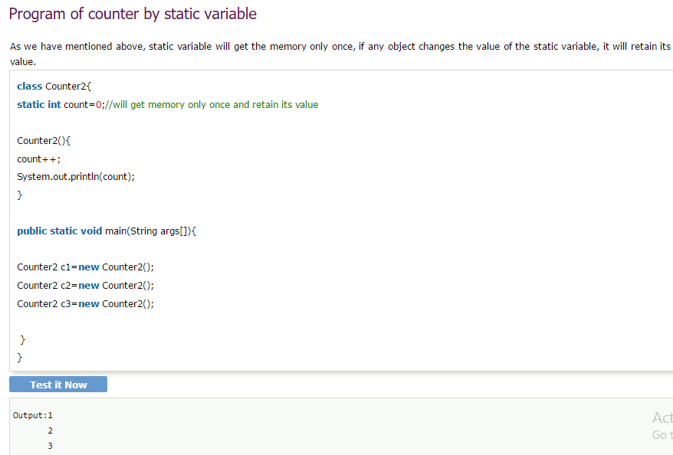

2. Java static method->

*If you apply static keyword with any method, it is known as static method.

* A static method belongs to the class rather than object of a class.
* A static method can be invoked without the need for creating an instance of a class.
* static method can access static data member and can change the value of it.

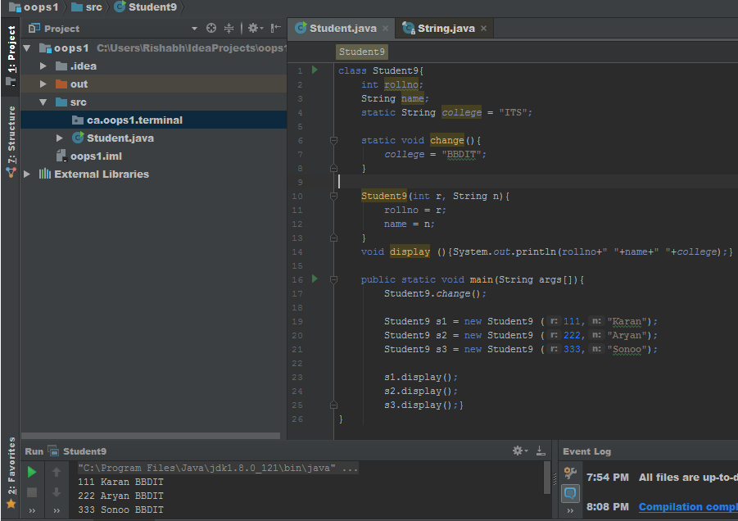

3.normal calculation without making object;

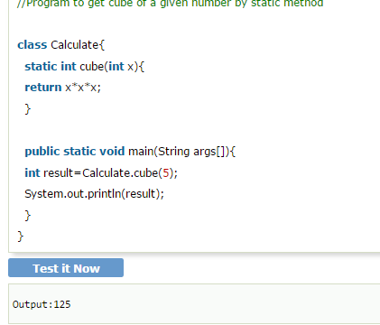

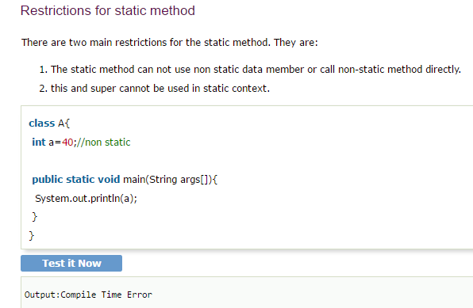

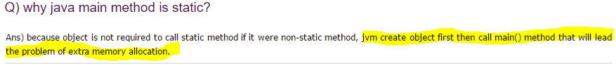

Jisse hum object na creat na krna pde;

3. java static block->

* Is used to initialize the static data member.
* It is executed before main method at the time of classloading.

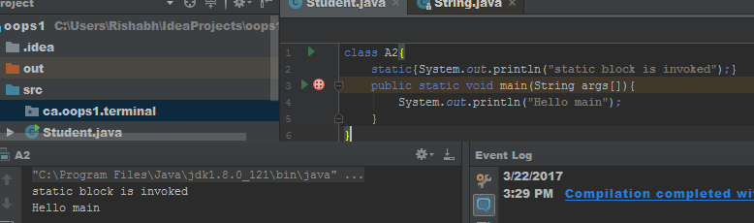

We can also make program without main () method by use static block;

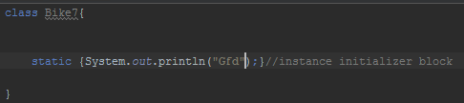

Normally when we do override then we call normal method first call the child class and if we put super it go

To super class then;

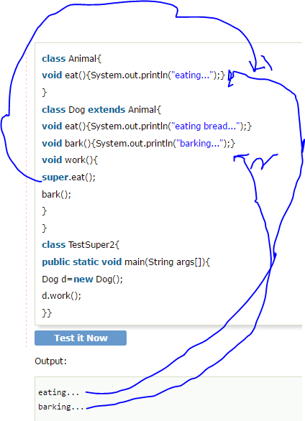

ONLY FOR CONSTRUCTOR IT HAPPEN->

